**Jared Dyreson**

**MWF 11 AM**

**Project 6**

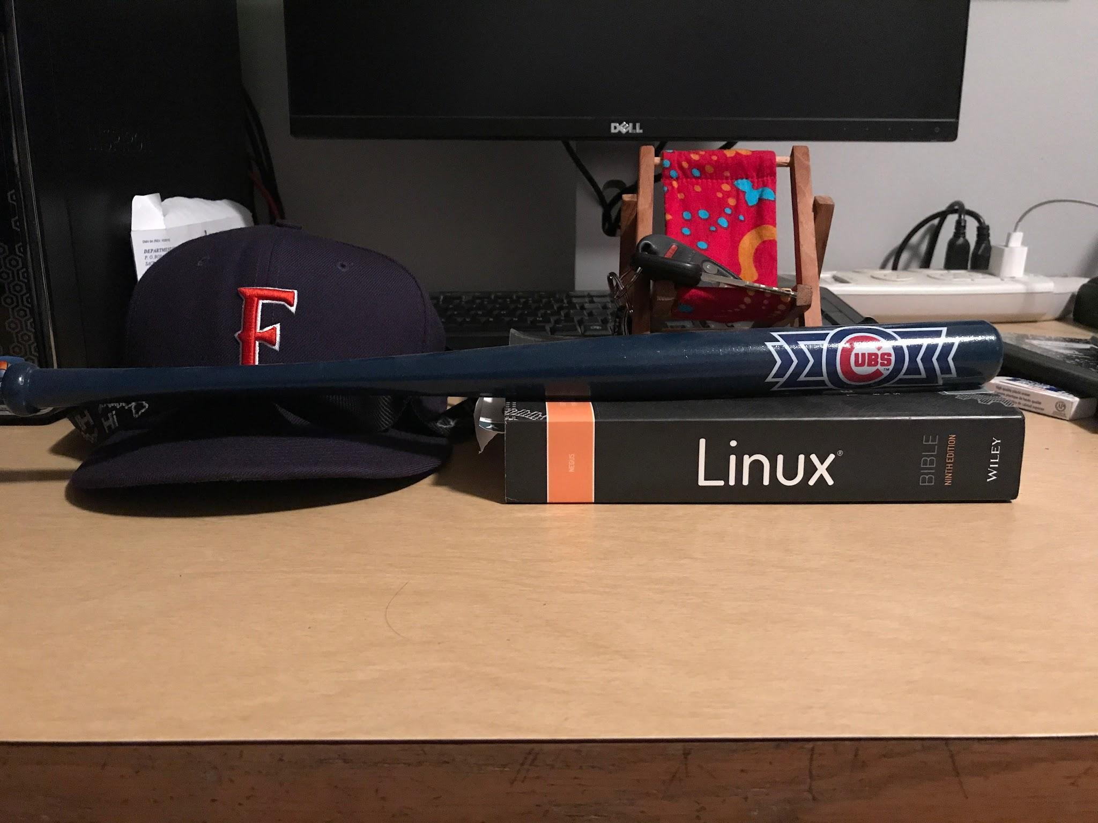

**Title:** A Summary of Life

**Category:**  Still Life

**Date Taken:**  October 28, 2017

**Camera Used:** iPhone 7 Plus

**Description**: This is a snapshot of who I am as person. The hat was given to me by my Dad, which he wore frequently in my childhood. I hold it very dearly to my heart. As for the bat, I am a new Cub fan even though my Dad has been rooting for them for his entire life; it took me a while to come around. For the keys, they are for the car that my Dad sold to me. The phone chair is a souvenir from the Hawaiian island Kauai from 2013; symbolizing that I am a laid back person. Lastly, the book is about my favorite operating system and a hint to my major; computer science.

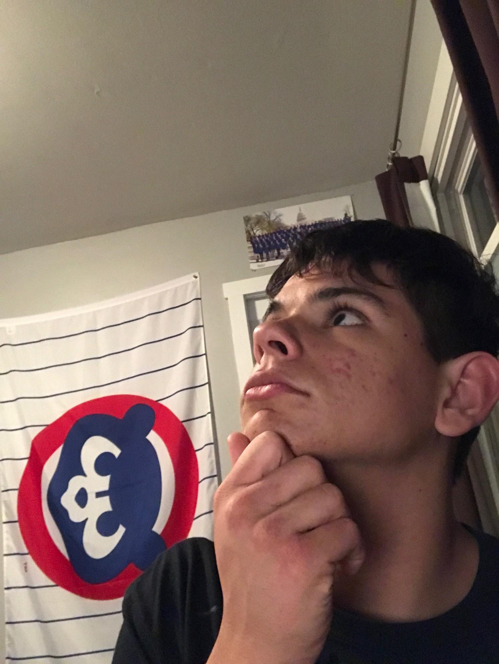

**Title:** Off in a thoughtful meadow

**Category:**  Self-Portrait

**Date Taken:**  October 28, 2017

**Camera Used:** iPhone 7 Plus

**Description**: This picture is of me in a very meaningful train of thought. Nah just kidding it is me being a goofball. Most of the time, I like to mess around and poke at people. Sometimes it’s not appreciated but I good laugh out of it. I don’t take things personally and try to be a free spirit which sometimes gets me in a bit of trouble. On second thought, I wonder why the Cubs didn’t win the National League Pennant this year….

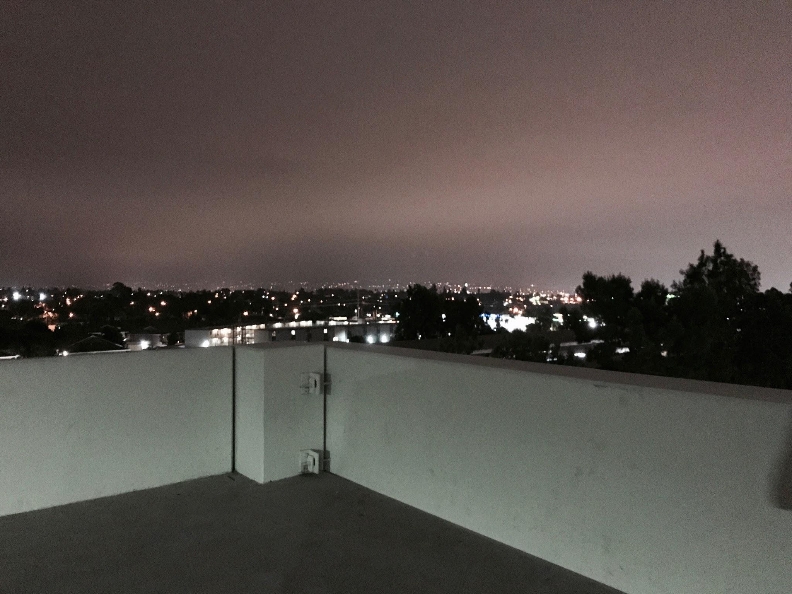

**Title:** Cloudy Skyline

**Category:**  Landscape

**Date Taken:**  October 29, 2017

**Camera Used:** iPhone 7 Plus

**Description**: This picture is of the skyline overlooked on the Nutwood parking structure next to the 57 freeway here at Cal State Fullerton. I really like this photo because it has muted yet vibrant colors at the same time. I achieved this by using a filter in the Camera App. I tried not to make the lights too bright as most cameras do not handle night photography well. What would make this photo even better is a latte and someone to talk to.

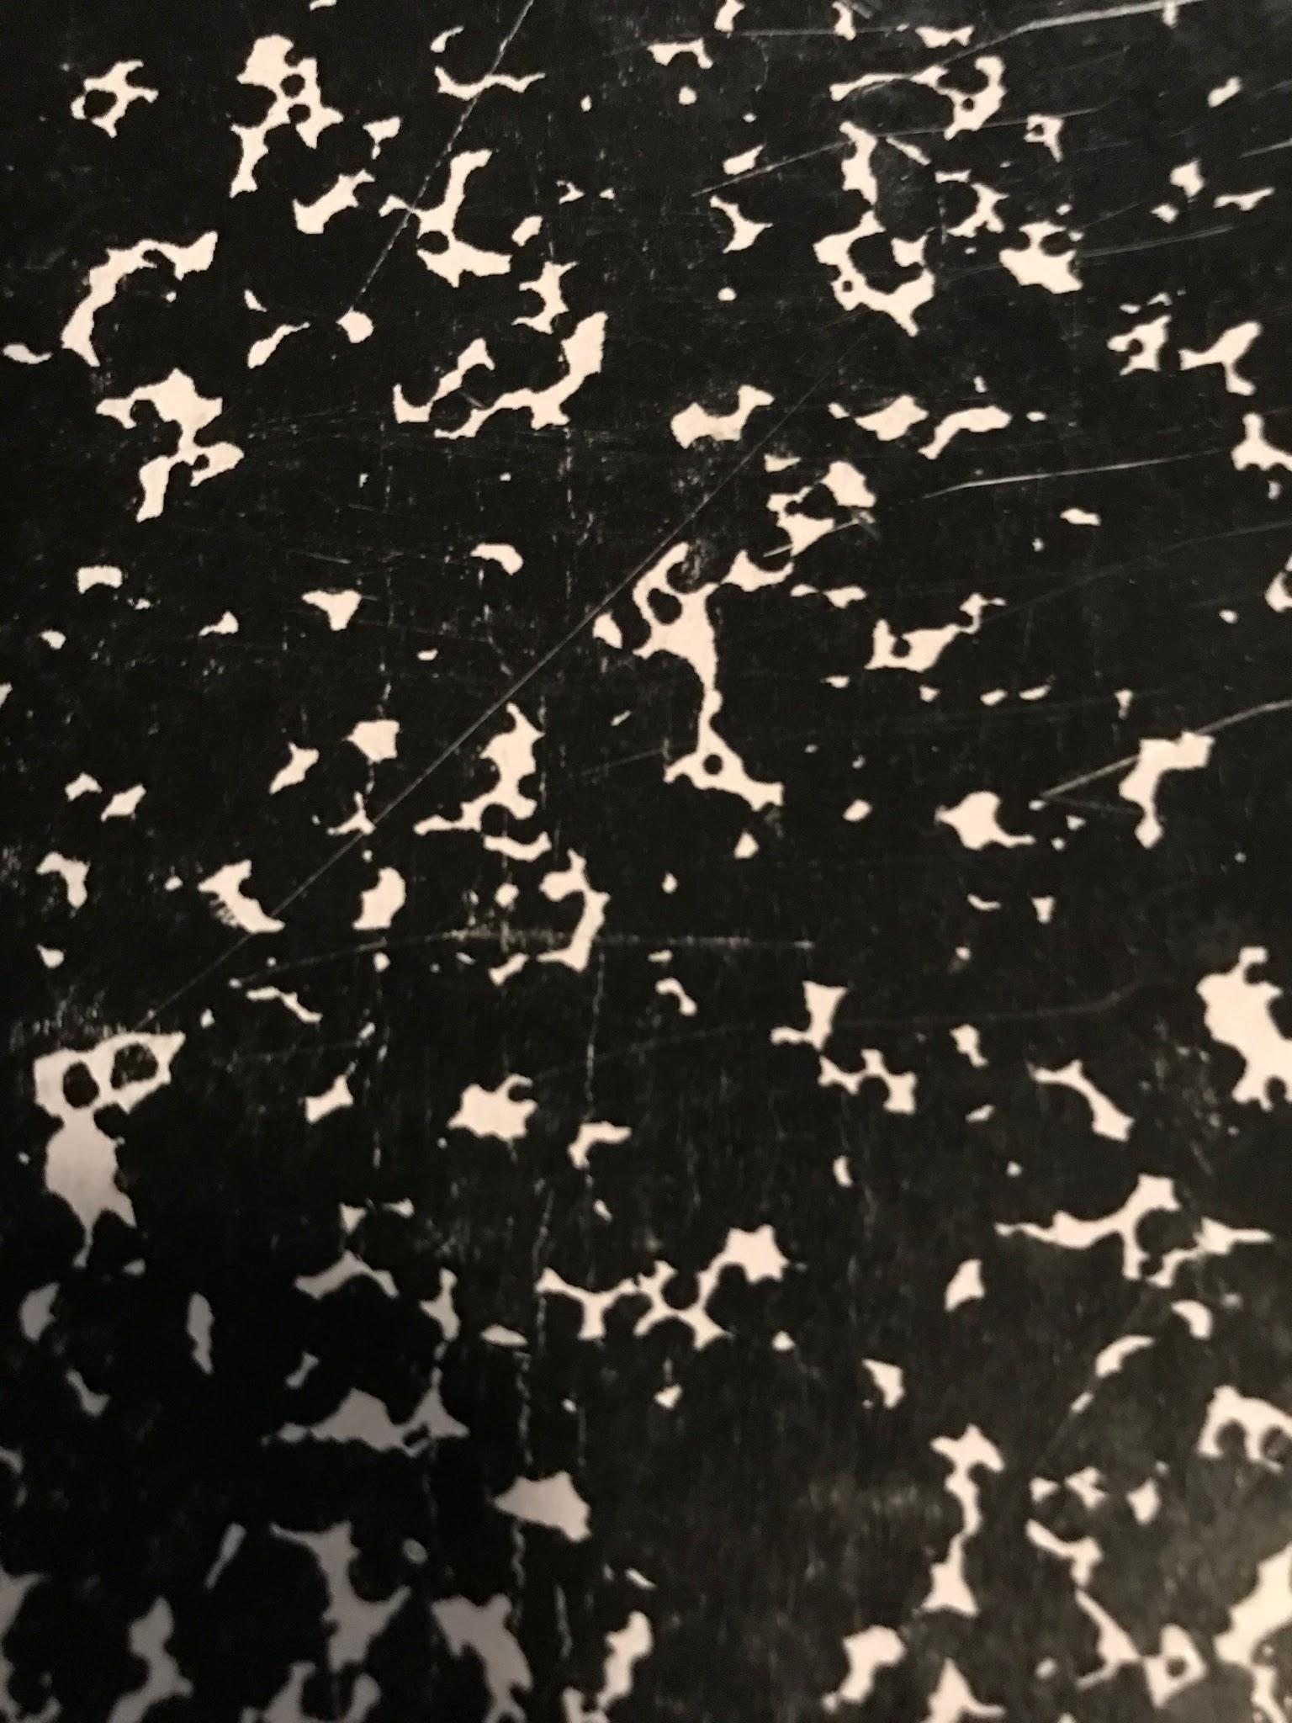

**Title:** School Cow

**Category:**  Non-objective

**Date Taken:**  October 28, 2017

**Camera Used:** iPhone 7 Plus

**Description**: This picture is of a closeup of my binder and it oddly resembles a Jackson Pollock painting; maybe I can sell it for lots of money. I named it “School Cow” because it also looks like the coat of a cow up close. The two colors, white and black, contrast each other and makes them pop. Some of the little white specks look like mini islands in a black and treacherous sea.

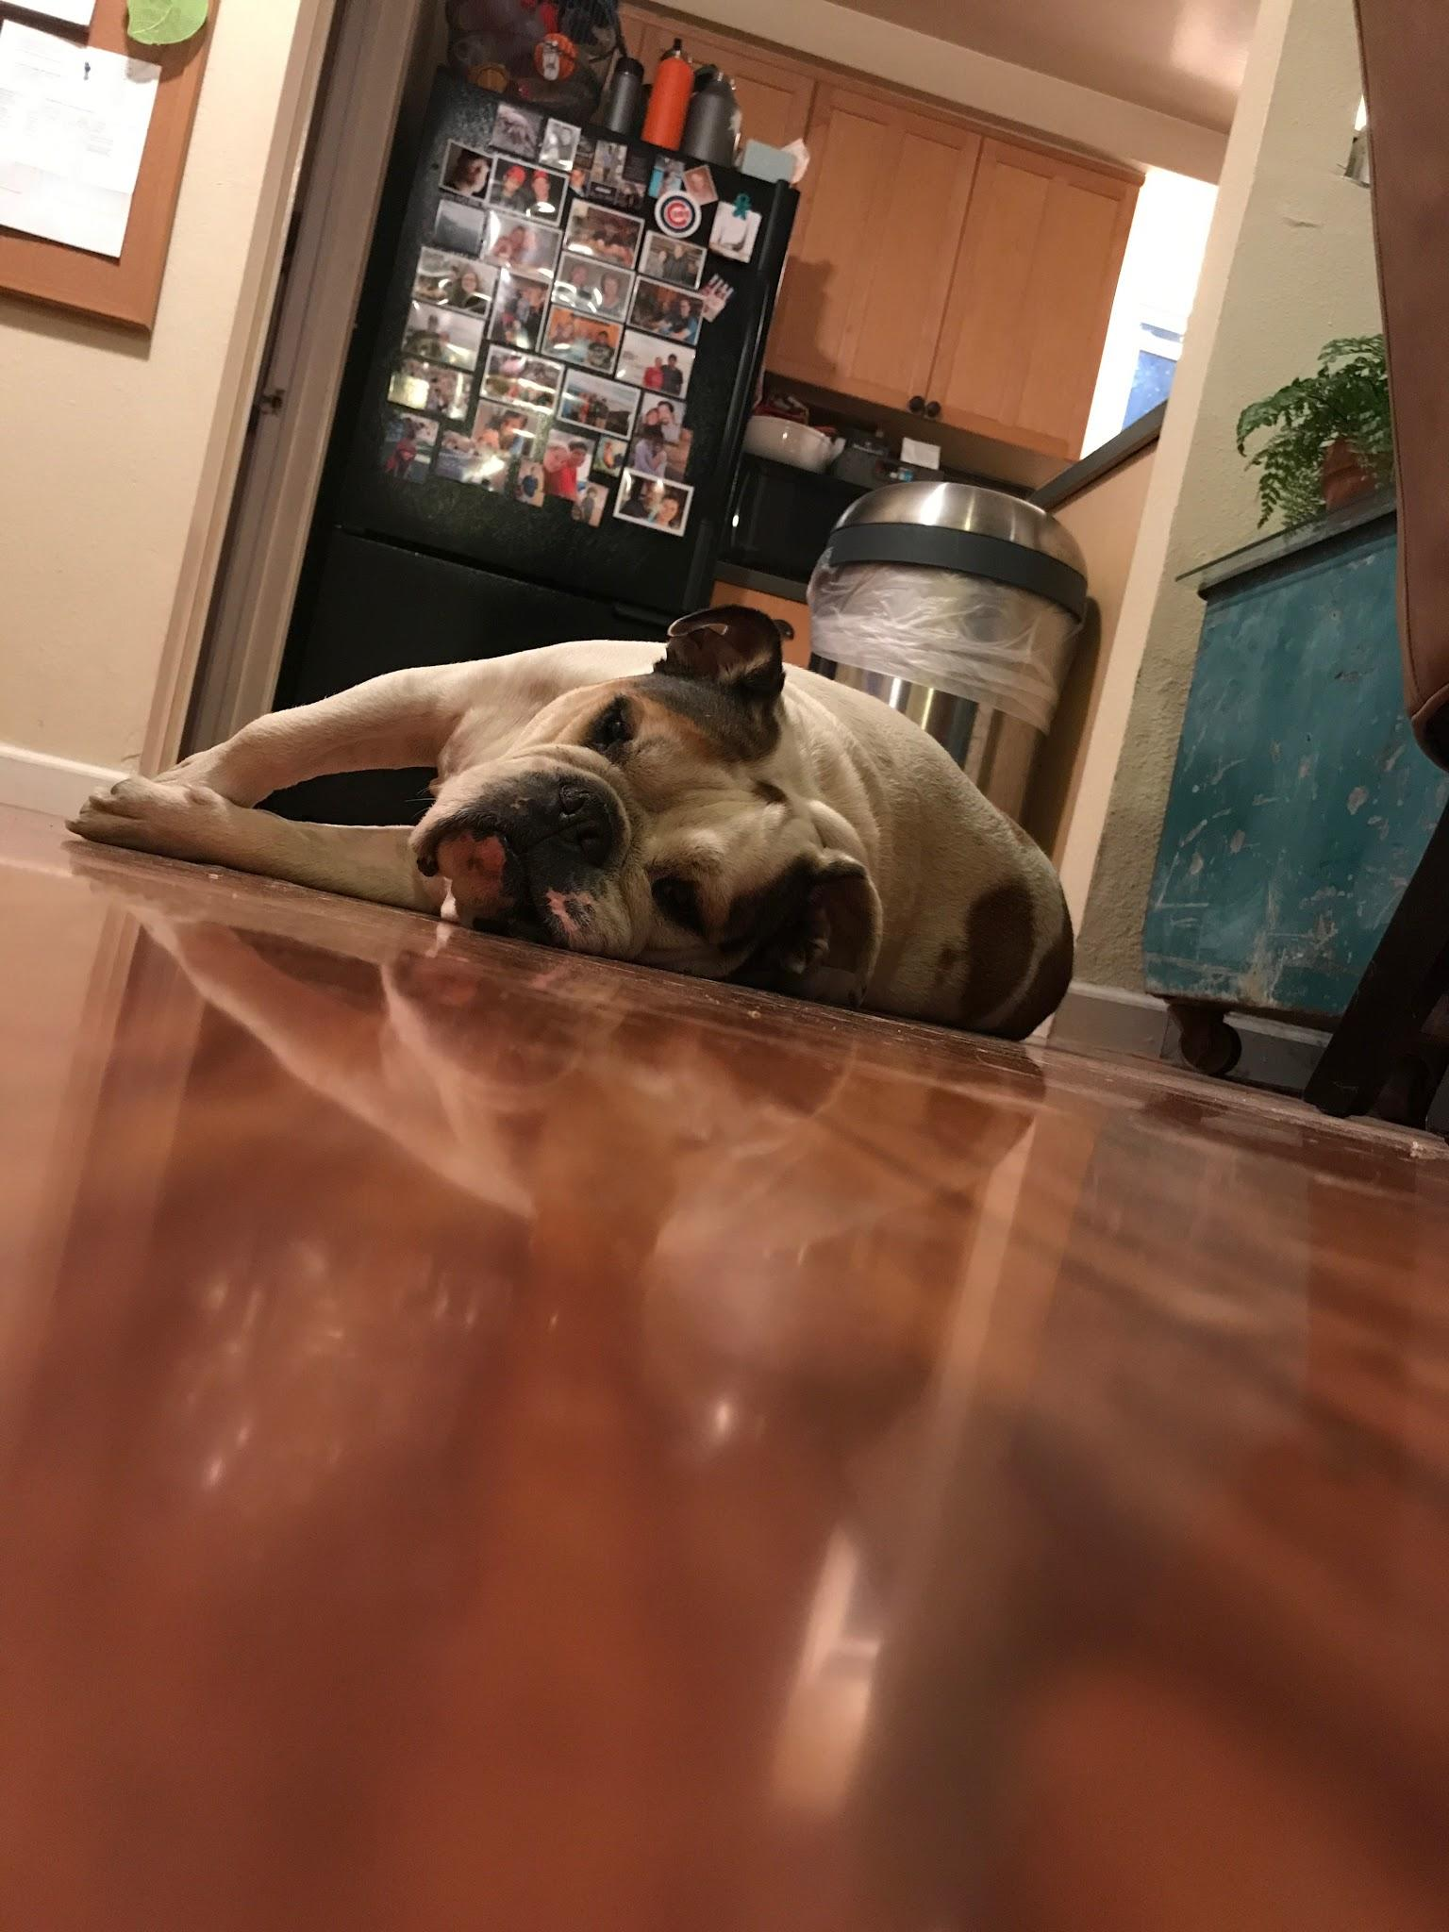

**Title:** Sleepy Dog

**Category:**  Personal Choice

**Date Taken:**  October 28, 2017

**Camera Used:** iPhone 7 Plus

**Description:** This picture is of my dog whose name is Flash but we call him Bubba because that better suits him. I chose this photo because I was stretching on the floor when I happen to see him behind me and I ended up really liking it. This is a very common position of my dog because he is quite lazy and sleeps often, resulting in loud snores and awful farts. My family loves Bubba to death but he can be a big pain in the neck some days. This happens to be a day where he isn’t a stubborn moose.